Test ID | Test Date | Who Did the Test | Where Testing Was Done | Screen Size / Device | Test Result
RST-01 | 21/09/2026 | Utsav Paudel | Localhost (XAMPP), Chrome | 1920 × 1080 — Desktop | Sample: Dashboard displayed correctly; no horizontal scrolling.
RST-02 | 21/09/2026 | Utsav Paudel | Localhost (XAMPP), Chrome | 1366 × 768 — Laptop | Sample: Navigation and medication tables displayed correctly.
RST-03 | 21/09/2026 | Utsav Paudel | Localhost (XAMPP), Chrome | 1376× 1032 — Small tablet | Sample: Content adjusted to the smaller screen; tables remained readable.
RST-04 | 21/09/2026 | Utsav Paudel | Localhost (XAMPP), Chrome DevTools | 960 × 1440 — Tablet portrait | Sample: Layout adapted to portrait orientation; controls remained accessible.
RST-05 | 21/09/2026 | Utsav Paudel | Localhost (XAMPP), Chrome DevTools | 440 × 956 — Mobile | Sample: Mobile layout displayed; buttons and text were usable.
RST-06 | 21/09/2026 | Utsav Paudel | Localhost (XAMPP), Chrome DevTools | 360 × 800 — Small mobile | Sample: Main content fitted the viewport; no unexpected horizontal overflow.

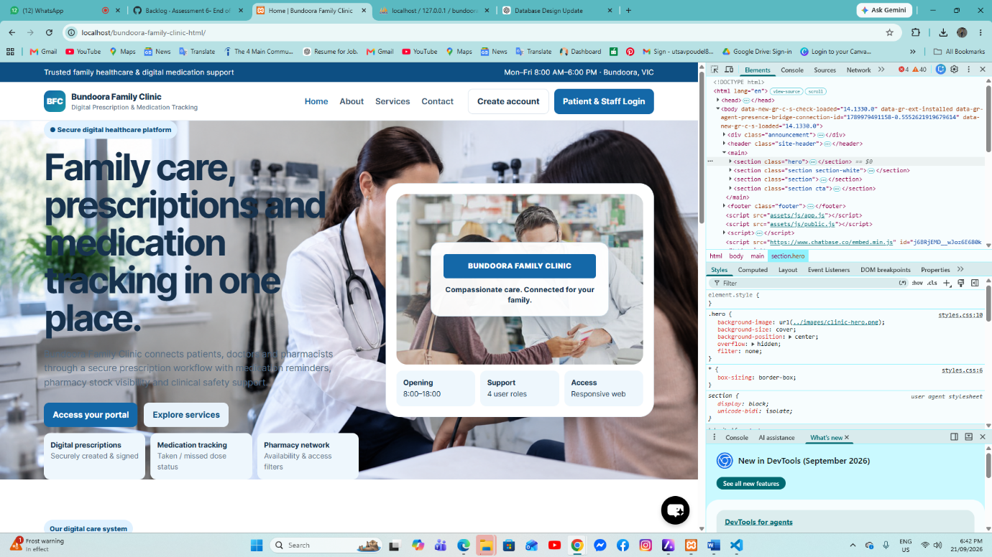
desktop view
The website is shown at full desktop width, with navigation and main content displayed clearly without horizontal scrolling.
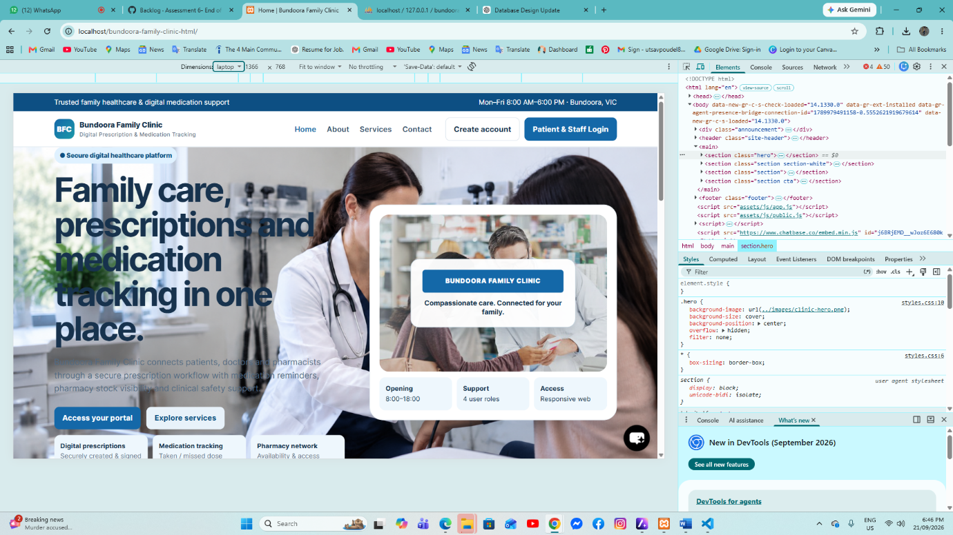laptop view
The layout remains well aligned on a laptop screen, with the navigation, hero section, and key controls clearly visible.
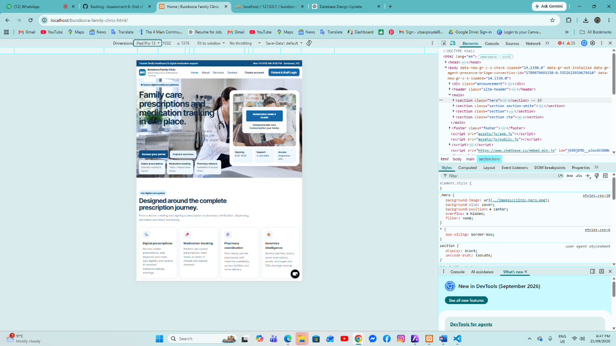ipad view
The page scales to the smaller iPad width, stacking content neatly while keeping text and sections readable.
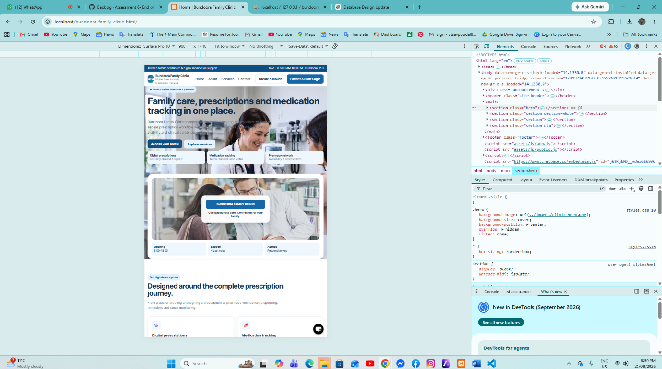tablet view
The tablet layout adapts smoothly to portrait view, keeping the main content and controls accessible.
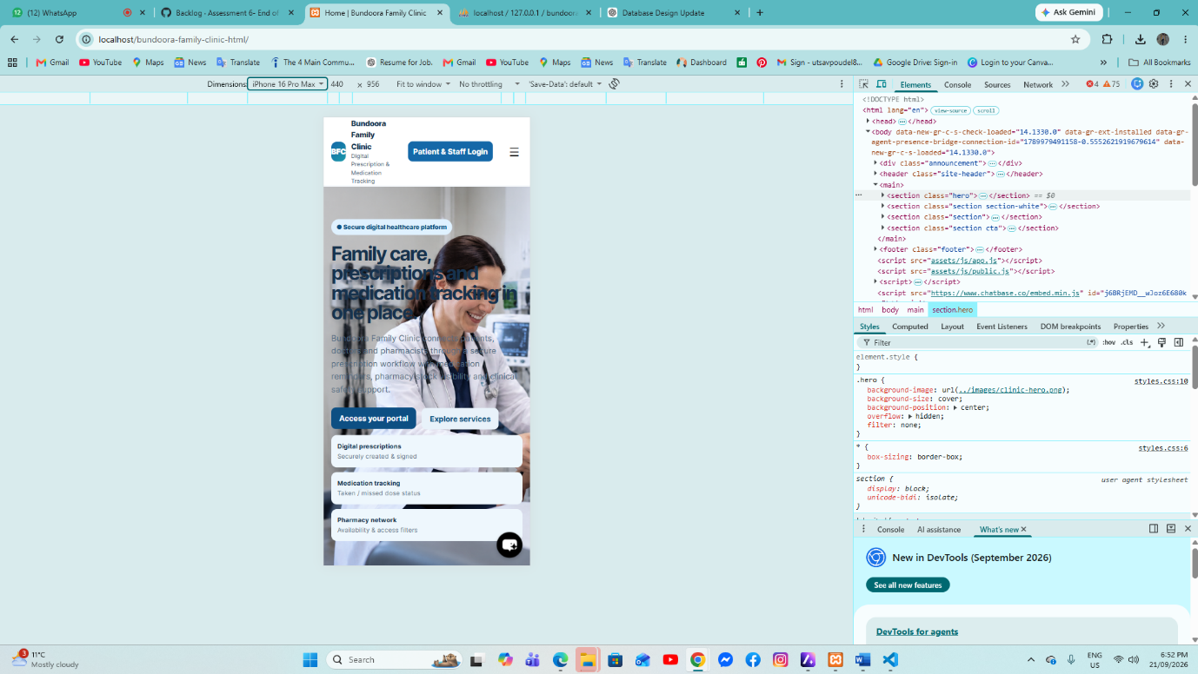iphone view
On iPhone, the content stacks vertically and the buttons, text, and navigation remain usable on the narrow screen.
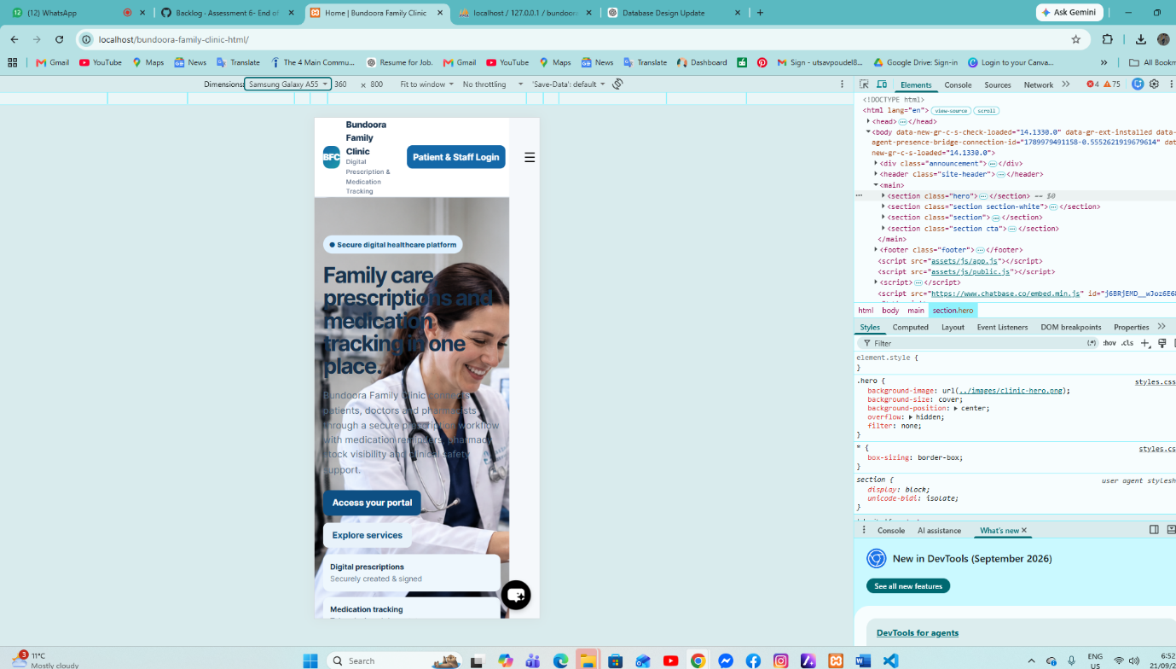mobile view
The small mobile view fits the viewport properly, with core content visible and no unexpected horizontal overflow.

